28.50: The fields add
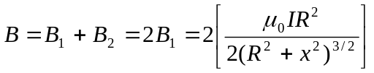
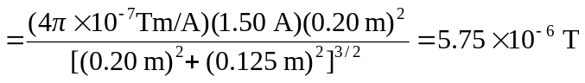
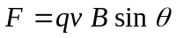
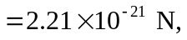 perpendicular to the line and to the velocity.

